An Easy Read Guide

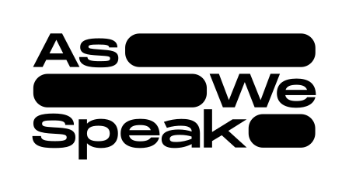

Exhibition
9th & 10th September 2022

- What’s an Easy Read?
This is an easy read guide for the As We Speak exhibition.

An Easy Read uses words and pictures to help people understand written information.

Easy Read Information is helpful for some people who:

- have a learning disability
- have low literacy levels
- use English as a second language
- are elderly
- are Deaf.

- About the exhibition
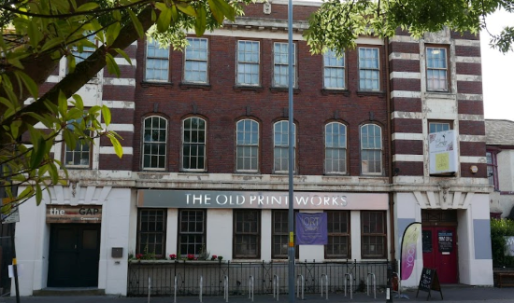 | As We Speak is happening at The Old Print Works.
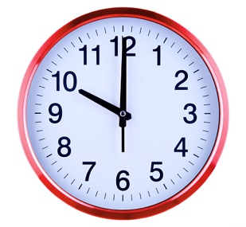  10.00 | The exhibition opens at 10am.
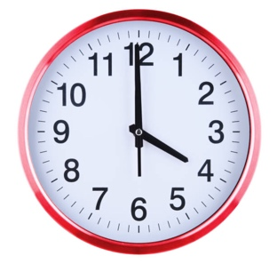  4.00 | The exhibition closes by 4pm.
 | This event is about the As We Speak project
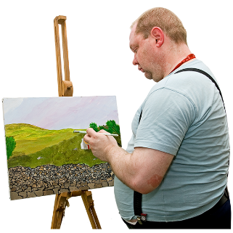 | It involved 10 artists from 8 countries making art.
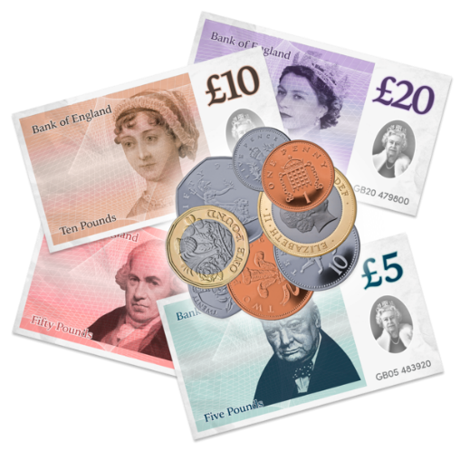 | This project was special because the artists weren’t told what they had to make.  Beatfreeks just gave them money to be artists. This is called “Trust-based Funding”
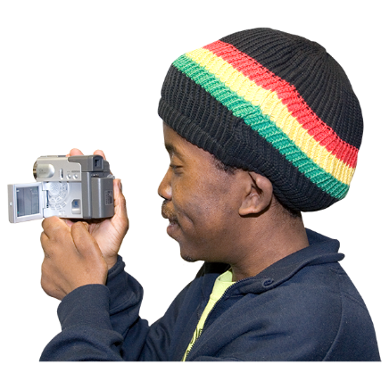 | Film-makers worked with the artists to record what this was like.
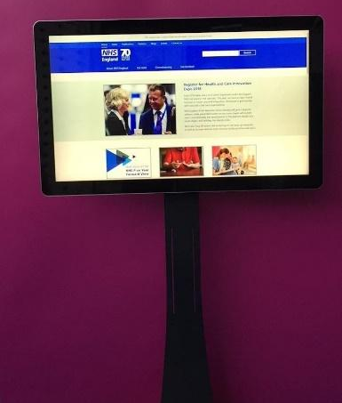 | At the event, the artists work will be shown for the first time using touch-screens.
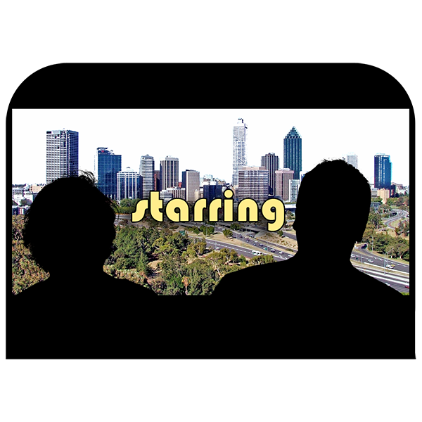 | There are 8 video commissions for you to watch.

- Getting There
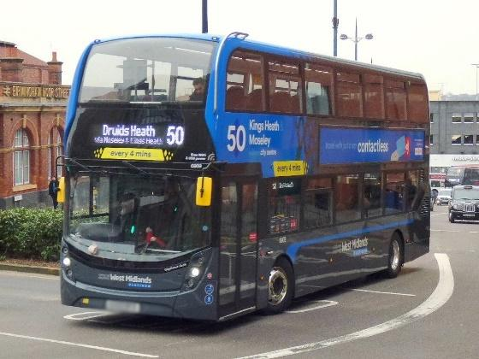 | The number 50 bus stops right outside.
If travelling by car, there is parking available on nearby streets.

There is extremely limited parking on site for disabled visitors.

There is more advice about how to travel to The Old Print Works here:
https://www.oldprintworks.org/getting-to-the-old-print-works

 | To enter use the main building entrance.
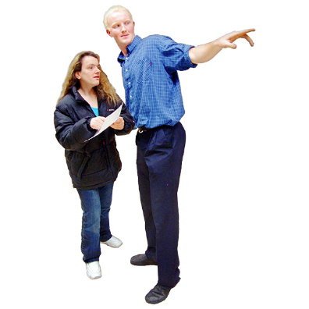 | If you need step free access ask the volunteer at the door.
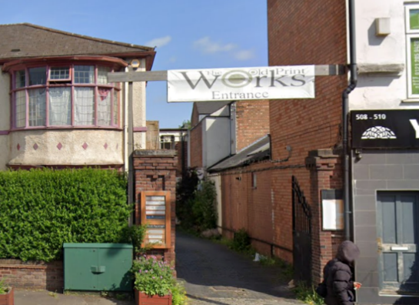 | They will show you to the courtyard entrance.
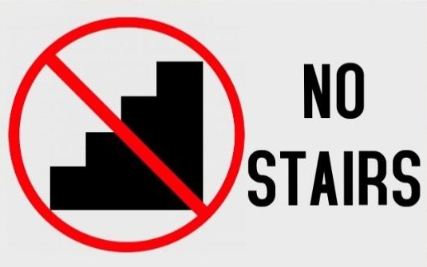 | This entrance is step-free.
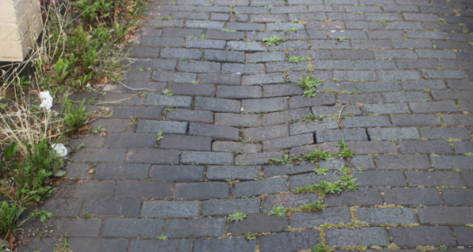 | The ground is uneven in some places.

- Here to help
 | If you need help at any point, there are likely to be one of two staff members on site - or volunteers.
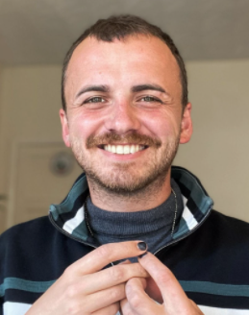 | This is Will.
 | This is Alanna.
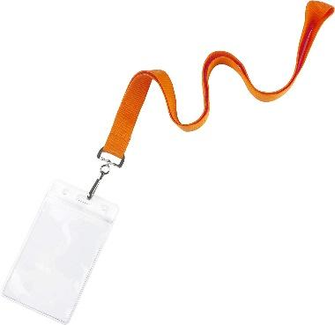 | There will also be volunteers at the exhibition wearing orange lanyards.
 | They can help give you directions, or answer questions about the event.

- Toilets
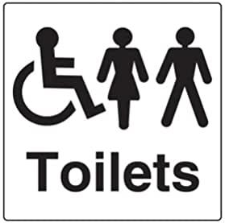 | There is one accessible toilet.
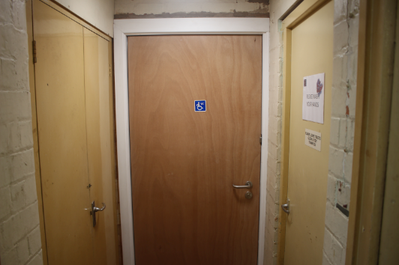 | It’s at the back of the building, about 150m from the main event space.
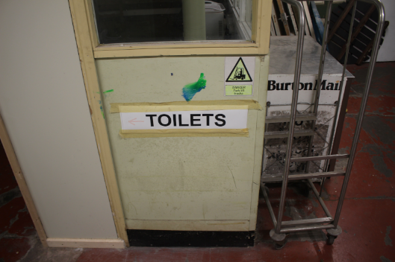 | There are signs on the walls to help guide you to the toilets.  There are also separate male and female toilets.
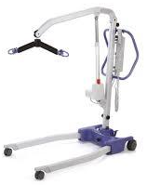 | Unfortunately, there are no hoists in any of the toilets on site.

- The Exhibition
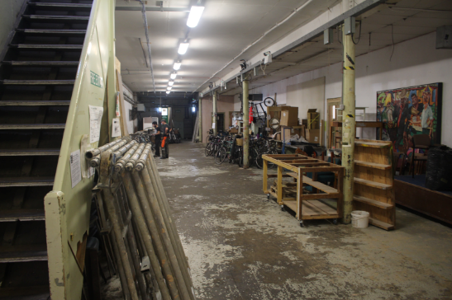 | The Exhibition is happening in the Lower Gallery.
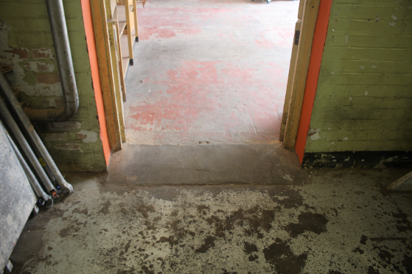 | This is next to The Drawing Room, and is accessed by a small ramp.
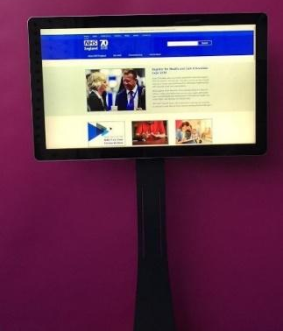 | There will be 8 touchscreens showing work created by the project artists.
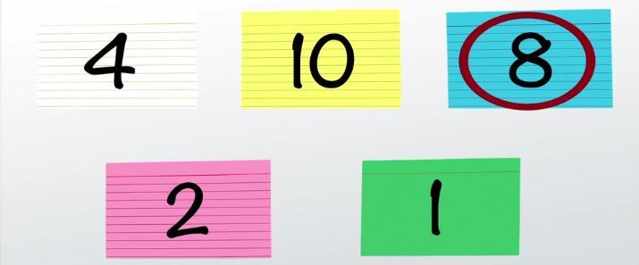 | You can watch them in any order.
 | One piece, by Urbansong, contains flashing lights.

- Surveys
 | You might be asked by one of the volunteers to fill in a survey.
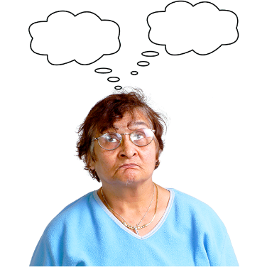 | This is a chance to let Beatfreeks know what you thought about the art and the project.
 | You don't have to fill in the survey if you don't want to.

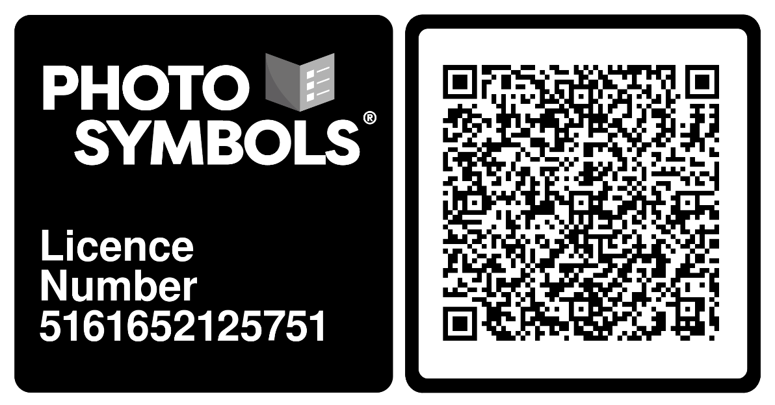
All Photographs used in this guide were taken by the author, provided by the venue & organisers, or taken from the PhotoSymbols Library.

